Elijah Andrushenko

011476324

David Bakken

CPTS 224

Homework 4

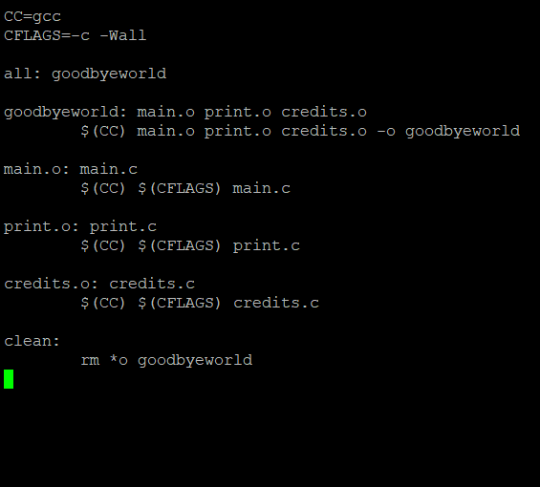

1.

2.

clean:

rm \*o goodbyeworld

3.

make: nothing to be done for ‘all’.

4.

gcc -c -Wall print.c

gcc main.o print.o credits.o -o goodbyeworld

5.

gcc -c -Wall print.c

gcc –c –Wall credits.c

gcc main.o print.o credits.o -o goodbyeworld